EMAIL VALIDATION USING FLEX
1. AIM
To write and execute a Lex/Flex program that scans an input text file and identifies strings matching a basic email-address pattern, displaying each matched email address.
2. SOFTWARE REQUIRED
- Flex (Fast Lexical Analyzer Generator)
- GCC compiler
- Command Prompt/Terminal
3. PSEUDOCODE
BEGIN
IF argc is not equal to 2 THEN
DISPLAY "Usage: program_name input.txt"
RETURN 1
END IF

OPEN the file specified by argv[1] in read mode
STORE the file pointer in fp

IF fp is NULL THEN
DISPLAY "Error opening file!"
RETURN 1
END IF

SET yyin = fp
CALL yylex() to scan the input file

WHEN text matches the email regular expression
DISPLAY "Valid Email: " followed by the matched text (yytext)
IGNORE every character or newline that does not match the email pattern

CLOSE fp
RETURN 0
END

4.OUTPUT
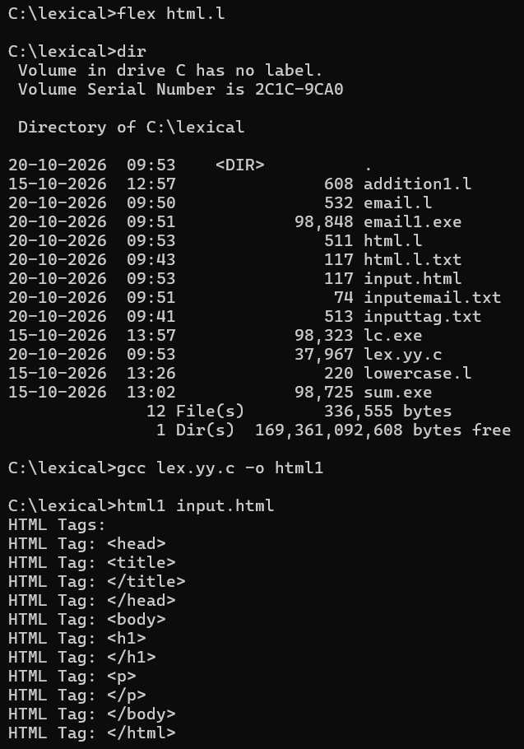

5.RESULT
The Flex program was designed to scan the given input file and display email-like strings that match the specified regular expression. The program successfully demonstrates pattern matching using Flex.
Note: This regular expression performs basic pattern matching only; it does not guarantee that an email address exists or satisfies every rule of the official email-address standard.

